

Requirement & Design Specification
Global Access Management System (GAMS)
Version: 1.0

– Hanoi, August 2022 –

Record of Changes
Version | Date | A*  M, D | In charge | Change Description
V1.0 | 15/2 | A | KienNTHE11
*A - Added M - Modified D - Deleted

Contents
Record of Changes 2
I. Overview 4
1. User Requirements 4
1.1 Actors 4
1.2 Use Cases 4
2. Overall Functionalities 5
2.1 Screens Flow 5
2.2 Screen Descriptions 5
2.3 Screen Authorization 5
2.4 Non-UI Functions 6
3. System High Level Design 6
3.1 Database Design 6
3.2 Code Packages 7
II. Requirement Specifications 8
1. <<Feature Name>> 8
1.1 <<UseCaseCode_UC Name>> 8
2. Common Functions 11
2.1 UC-2_Login System 11
3. Patron Feature 12
3.1 UC-5_Order a Meal 12
3.2 UC-6_Register for Payroll Deduction 13
III. Design Specifications 14
1. <<Feature Name>> 14
1.1 <<SubFeature Name>> 14
1.2 System Access 15
IV. Appendix 19
1. Assumptions & Dependencies 19
2. Limitations & Exclusions 19
3. Business Rules 19
4. .. 19

I. Overview

1. User Requirements

1.1 Actors
# | Actor | Description
1 | Admin | The system administrator with the highest privilege level. Responsible for managing the lifecycle of internal user accounts (provisioning, role assignment, and deactivation of Manager and Staff accounts), configuring system-wide parameters, and auditing the entire system through comprehensive audit logs for incident traceability. All administrative actions are persisted in the audit trail. To prevent self-lockout, the Admin is restricted from modifying their own role or deactivating their own account.
2 | Manager | A mid-level operational supervisor whose account is provisioned by the Admin. Responsible for approving or rejecting voucher submissions raised by Staff, performing emergency deactivation of active vouchers upon detection of fraud or abuse, modifying approved vouchers within permitted boundaries (extending the validity period, increasing the issuance quota), reviewing campaign performance analytics, executing bulk voucher creation via CSV import, monitoring Staff performance metrics derived from customer ratings, and hiding feedback entries containing policy-violating content. To enforce segregation of duties (SoD), the Manager is prohibited from approving vouchers authored by themselves.
3 | Staff | An operational user whose account is provisioned by the Admin. Responsible for drafting new voucher records, submitting drafts for managerial approval, modifying or discarding their own drafts prior to submission, retrieving the redemption history of a specific Customer for support and dispute resolution, and issuing personalized vouchers to Customers under exceptional circumstances (goodwill compensation, complaint resolution). Staff operations are scoped strictly to voucher records authored by the same user.
4 | Customer | The end user of the system who self-registers via email/password credentials or authenticates through a third-party identity provider (OAuth-based social login). Interacts with the system to browse the catalog of eligible active vouchers, redeem a voucher against an order at checkout to obtain a discount, review their personal redemption history, submit and edit ratings for the service experience after voucher redemption, and submit and edit ratings for Staff members who have provided support. Customer access is strictly scoped to their own data; no access to internal operational data is permitted.

1.2 Use Cases
[A use case (UC) describes a sequence of interactions between a system and an external actor that results in the actor being able to achieve some outcome of value. The names of use cases are always written in the form of a verb followed by an object. Select strong, descriptive names to make it evident from the name that the use case will deliver something valuable for some user]

a. Diagram(s)
[Provide the UC diagram(s) to show the actor-UCs and UC-UC relationships like the sample below. You can have multiple UC diagrams for the system]
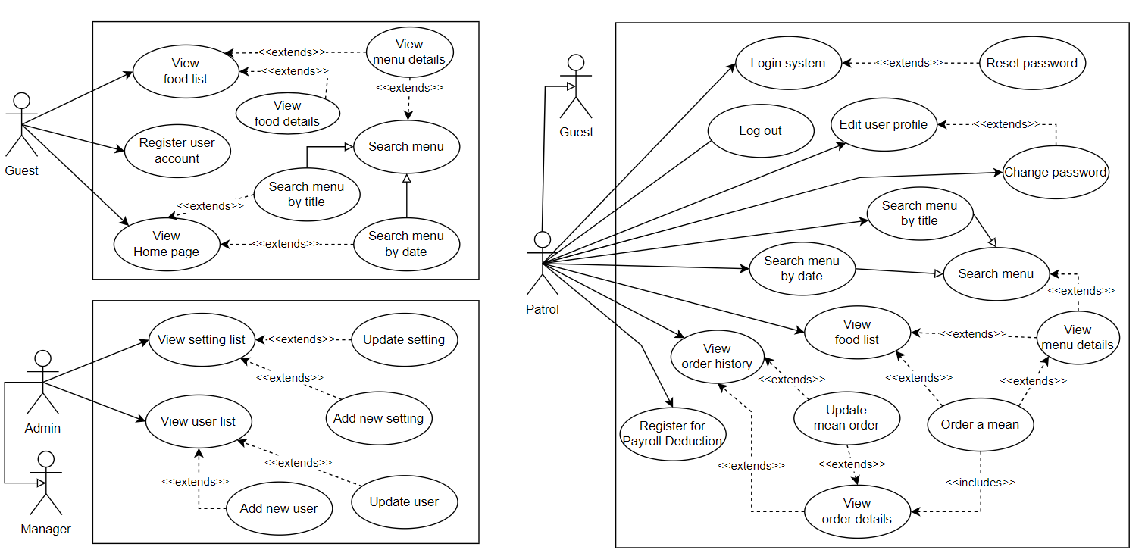

b. Descriptions
This part describes the use cases, you can follow the table form as below]
ID | Feature | Use Case | Use Case Description
01 | Authentication & Account Management | Register Customer Account | Allows a new customer to self-register an account by providing email and password credentials, with the password hashed using BCrypt. The account is created with the default Customer role in a pending-verification state and is not active until the email is verified. Self-registration with elevated roles (Staff, Manager, Admin) is prohibited.
02 | Authentication & Account Management | Authenticate User | Allows a registered user to log in via email and password; the system verifies credentials, confirms the account is active, and issues a JWT access token and refresh token with the user’s role embedded. Pending-verification and deactivated accounts are rejected, and the account is locked for 15 minutes after five consecutive failed attempts.
03 | Authentication & Account Management | Provision Internal User Account | Allows the Admin to create internal user accounts for Staff and Manager roles. The system generates a temporary password, emails it to the new employee, enforces a password change on first login, and records the event in the audit trail.
04 | Authentication & Account Management | Deactivate User Account | Allows the Admin to deactivate any user account upon employee departure or terms-of-service violation. The system sets the account to inactive, blocks subsequent logins, and invalidates active JWT tokens via a token blacklist.
05 | Voucher Authoring | Create Voucher Draft | Allows a Staff or Manager to create a new voucher in Draft state with all required attributes such as code, discount type and value, validity period, quotas, and minimum order amount. Drafts are not visible to customers and remain editable by their author until submitted.
06 | Voucher Authoring | Manage Voucher Draft | Allows the original author to modify or discard their own Draft vouchers prior to submission. Editing is restricted to records owned by the requesting user and currently in Draft state.
07 | Approval Workflow | Submit Voucher for Approval | Allows a voucher author to transition a Draft voucher into the Pending Approval state. The system runs a full validation rule set, locks the record from further authoring edits, notifies all active Managers, and writes an audit log entry.
08 | Approval Workflow | View Pending Approval Queue | Allows a Manager to view vouchers awaiting approval, sorted in first-in-first-out order by submission time. The view exposes voucher details, author identity, submission time, and the business conditions needed for an approval decision.
09 | Approval Workflow | Review Voucher Submission | Allows a Manager to approve or reject a Pending voucher, where approval activates it for redemption and rejection requires a mandatory reason. The system enforces segregation of duties by prohibiting Managers from reviewing vouchers they authored.
10 | Voucher Maintenance | Modify Approved Voucher | Allows a Manager to amend an approved voucher within defined boundaries: the validity end date may only be extended, the total quantity only increased, and the description edited freely. Discount parameters become immutable once redemptions exist.
11 | Voucher Maintenance | Deactivate Active Voucher | Allows a Manager or Admin to perform an emergency soft-delete on an active voucher upon detection of fraud, error, or abuse. The voucher is removed from customer eligibility, redemption history is preserved, and a mandatory reason is captured in the audit trail.
12 | Customer Redemption | Browse Eligible Vouchers | Allows a Customer to view vouchers currently available for their use, filtered to those that are approved, within validity, within quota, and not soft-deleted. Each entry shows redemption conditions and the customer’s remaining personal allowance.
13 | Customer Redemption | Redeem Voucher at Checkout | Allows a Customer to apply a voucher code to their order at checkout. The system atomically validates the full redemption rule chain, computes the discount according to discount type, persists the redemption record, and applies the discount under transactional concurrency control.
14 | Customer Redemption | View Personal Redemption History | Allows a Customer to view their own redemption history, sorted by redemption time descending, showing voucher code, associated order, discount amount, and date. Access is strictly scoped to the requesting customer’s records.
15 | Support & Analytics | Lookup Customer Redemption History | Allows a Staff member to search a specific customer’s redemption history by email or order code for complaint resolution and support. Every lookup is persisted in the audit trail to deter unauthorized data access.
16 | Support & Analytics | View Campaign Performance Dashboard | Allows a Manager to view aggregated voucher-campaign analytics, including total issuance, total redemptions, redemption rate, total discount value, and the top ten most-redeemed vouchers. The dashboard supports filtering by time range and by voucher author.
17 | Support & Analytics | View System Audit Log | Allows the Admin to inspect the audit trail of critical system actions such as voucher lifecycle events, approval decisions, role changes, and account deactivations. The log supports filtering by actor, action type, and time range, and CSV export.
18 | Rating & Feedback | Submit Service Rating | Allows a Customer to submit a 1–5 star rating with an optional comment for the service experience after completing a redemption. The system verifies eligibility, enforces one rating per transaction, and publishes the content immediately.
19 | Rating & Feedback | Submit Staff Rating | Allows a Customer to submit a 1–5 star rating with an optional comment for a Staff member who provided support. The system enforces one rating per customer per staff member, and redirects to the edit flow when a rating already exists.
20 | Rating & Feedback | Edit Own Rating | Allows a Customer to modify the star rating or comment of a previously submitted rating, for both service and staff ratings. The system verifies ownership and records the update timestamp for audit purposes.
21 | Rating & Feedback | View Service Ratings | Allows any Customer or guest visitor to view visible service ratings with aggregate metrics such as average rating, total count, and star distribution. Hidden ratings are excluded from the list and aggregates, and customer identities are privacy-masked.
22 | Rating & Feedback | View Staff Performance | Allows a Manager to view aggregated rating metrics per Staff member, including average rating, total count, star distribution, and visible comments. The report supports filtering by time range and CSV export for periodic reviews.
23 | Rating & Feedback | Hide Violating Feedback | Allows a Manager to hide a feedback entry containing policy-violating content such as spam, inappropriate language, or defamation. The action requires a mandatory reason, is recorded in the audit log, and notifies the affected Customer.
24 | Authentication & Account Management | Verify Account Email | Allows a newly registered customer to activate their account by following the verification link sent to their email. The system validates the single-use token, transitions the account from pending-verification to active, and grants login capability; an expired token offers a guided resend.
25 | Authentication & Account Management | Reset Forgotten Password | Allows a registered user to reset a forgotten password through an email-based flow, where the request response is identical whether or not the email exists to prevent account enumeration. After the user sets a new password via a single-use reset link, the system invalidates all existing access and refresh tokens.
26 | Booking Management | Create Booking | Allows a Customer to book a wash service by selecting a service type, vehicle, and available time slot. The system enforces the tier-based booking window, locks the slot to prevent double-booking, optionally auto-applies the best eligible promotion, and emails a booking confirmation.
27 | Booking Management | Send Booking Reminder | A scheduled use case in which the system periodically finds confirmed bookings starting within the upcoming reminder window that have not yet been reminded, and emails each customer a reminder of the service and appointment time. Each booking is marked as reminded so it is never reminded twice.
28 | Booking Management | Cancel Booking | Allows a Customer to cancel a confirmed booking before its scheduled time, subject to a cancellation cut-off rule. The system releases the held slot and any auto-applied promotion, sets the booking to cancelled, and emails a cancellation confirmation.
29 | Booking Management | View My Bookings | Allows a Customer to view their own upcoming and historical bookings, sorted by appointment time, showing service type, vehicle, date and time, status, and any applied promotion. Access is strictly scoped to the requesting customer’s records.
30 | Booking Management | Check-in Booking | Allows a Staff member to check in a customer on arrival by scanning the booking code or entering the license plate. The system displays the customer, loyalty tier, and booked service, and transitions the booking to checked-in; cancelled or no-show bookings are rejected.
31 | Booking Management | Complete Booking | Allows a Staff member to mark a checked-in booking as completed once the wash service has been delivered. The system records the completion time and makes the transaction eligible for loyalty point accrual and service rating.
32 | Booking Management | Mark Booking No-show | A scheduled use case in which the system transitions confirmed bookings whose scheduled time has elapsed without a check-in into the no-show state; a Staff member may also trigger this manually. The no-show state supports booking analytics and customer reliability tracking.
33 | Booking Management | Manage Booking Slots | Allows a Manager to configure the shop’s bookable capacity, including operating hours, wash bays, service durations, and blocked dates. The system derives available slots dynamically so capacity changes take effect for all future bookings immediately.
34 | Approval Workflow | Revise Rejected Voucher | Allows the original author of a rejected voucher to view the rejection reason, edit the voucher, and either return it to Draft or resubmit it for approval. This keeps a rejected voucher within the editable workflow rather than in a terminal state.
35 | Customer Redemption | Reverse Voucher Redemption | Allows the system to reverse a voucher redemption when the associated order is cancelled or refunded. The redemption record is marked as reversed, one unit is returned to both the total quota and the customer’s allowance, and an audit entry is written.
36 | Voucher Maintenance | Expire Vouchers | A scheduled use case in which the system periodically transitions active vouchers whose validity end date has passed into the expired state, removing them from customer eligibility and browse-eligible results.
37 | Authentication & Account Management | Change Password | Allows an authenticated user to change their own password within an active session by supplying the current and new password. The system re-verifies the current password, validates and hashes the new one with BCrypt, and invalidates other active sessions.
38 | Authentication & Account Management | Refresh Access Token | Allows an authenticated client to obtain a new JWT access token by presenting a valid refresh token, so the session continues beyond the access-token lifetime without re-entering credentials. Expired, revoked, or blacklisted refresh tokens are rejected.

2. Overall Functionalities

2.1 Screens Flow
[This part shows the system screens and the relationship among screens. You can draw the Screens Flow for the system in the form of diagram as below. Please note that beside the normal flat screen, we might have the oval notation for pop-up screen (Import Order) or a screen with multiple information tab (Order Details), etc. You may also use text or background format for different visuality purpose]
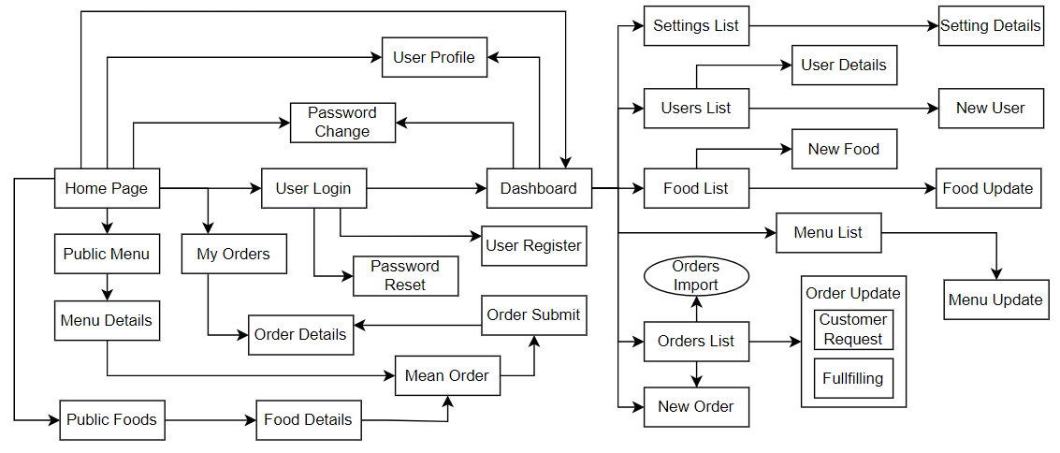

2.2 Screen Descriptions
[Provide the descriptions for the screens in the Screens Flow above]
# | Feature | Screen | Description
1 | Order Meals | Create Order | <<Screen Brief description>>
2 | Order Meals | Change Order
3 | ..

2.3 Screen Authorization
[Provide the system roles authorization to the system features (down to screens, and event to the screen activities if applicable) in the table form as below – replace Role1, Role2,… with your specific system user role names]
Screen | Admin | Manager | Staff | Customer
<<Screen Name1>> | X |  | X | X
<<Screen Activity>> |  |  | X | X
<<Screen Name2>> | X |  | X
Query All Data | X
Query Own Data |  |  | X
Query Managed Data |  |  | X
Add New Data |  |  | X | X
Update All Data |  |  |  | X
Update Own Data |  |  |  | X
Update Managed Data |  |  |  | X
Delete Data
…

2.4 Non-UI Functions
[Provide the descriptions for the functions which have no UI (or not screens), i.e batch/cron job, service, API, etc.]
# | Feature | System Function | Description
1 | <<Feature Name>> | <<Function Name1>> | <<Function Name1 Description>>
2 | …

3. System High Level Design

3.1 Database Design
[Provide the tables relationship like example below]

a. Database Schema

b. Table Descriptions
No | Table | Description
01 | <Table name> | <Description of the table>  - Primary keys: <<list of primary key fields>>  - Foreign keys: <<list of foreign key fields>>
02 | <Table name2> | …

3.2 Code Packages
[Provide the package diagram for each sub-system. The content of this section including the overall package diagram, the explanation, package and class naming conventions in each package. Please see the sample & description table format below]
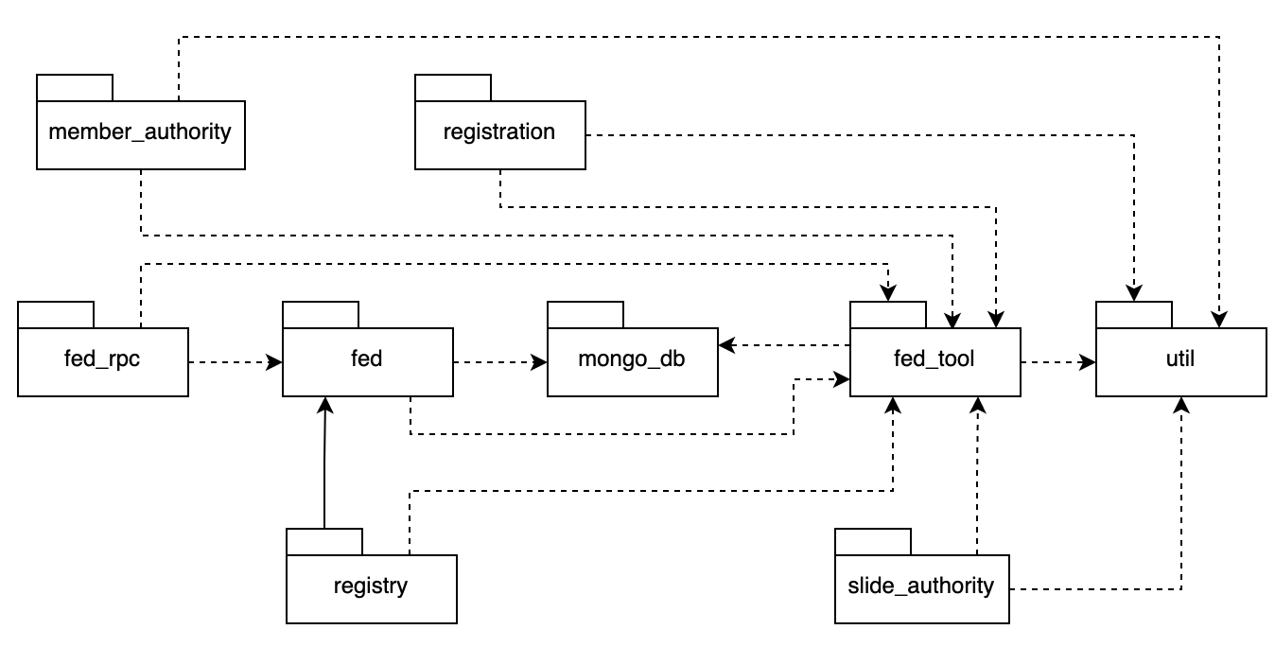
Package descriptions
No | Package | Description
01 | Member_authority | <Description of the package>
02 | registration | <Description of the package>
03 | …

II. Requirement Specifications

1. <<Feature Name>>

1.1 <<UseCaseCode_UC Name>>

a. Functionalities
Provide the functional description for the use cases using the template/guides below
Functional Description Template
UC ID and Name:
Created By: |  | Date Created:
Primary Actor: |  | Secondary Actors:
Trigger:
Description:
Preconditions:
Postconditions:
Normal Flow:
Alternative Flows:
Exceptions:
Priority: | High (Medium, Low), Must Have (Should Have, Could Have),..
Frequency of Use:
Business Rules:
Other Information:
Assumptions:

Functional Description Contents
Use Case ID and Name
Give each use case a unique integer sequence number identifier. State a concise name for the use case that indicates the value the use case would provide to some user. Begin with an action verb, followed by an object.
Author and Date Created
Enter the name of the person who initially wrote this use case and the date it was written.
Primary and Secondary Actors
An actor is a person or other entity external to the software system being specified who interacts with the system and performs use cases to accomplish tasks. Different actors often correspond to different user classes, or roles, identified from the customer community that will use the product. Name the primary actor that will be initiating this use case and any other secondary actors who will participate in completing execution of the use case.
Trigger
Identify the business event, system event, or user action that initiates the use case. This trigger alerts the system that it should begin testing the preconditions for the use case so it can judge whether to proceed with execution.
Description
Provide a brief description of the reason for and outcome of this use case, or a high-level description of the sequence of actions and the outcome of executing the use case.
Preconditions
List any activities that must take place, or any conditions that must be true, before the use case can be started. The system must be able to test each precondition. Number each precondition. Example: PRE-1: User’s identity has been authenticated.
Postconditions
Describe the state of the system at the successful conclusion of the use case execution. Label each postcondition in the form POST-X, where X is a sequence number. Example: POST-1: Price of item in the database has been updated with the new value.
Normal Flow
Provide a description of the user actions and corresponding system responses that will take place during execution of the use case under normal, expected conditions. This dialog sequence will ultimately lead to accomplishing the goal stated in the use case name and description. Show a numbered list of actions performed by the actor, alternating with responses provided by the system. The normal flow is numbered “X.0”, where “X” is the Use Case ID.
Alternative Flows
Document other successful usage scenarios that can take place within this use case. State the alternative flow, and describe any differences in the sequence of steps that take place. Number each alternative flow in the form “X.Y”, where “X” is the Use Case ID and Y is a sequence number for the alternative flow. For example, “5.3” would indicate the third alternative flow for use case number 5. Indicate where each alternative flow would branch off from the normal flow, and if pertinent, where it would rejoin the normal flow.
Exceptions
Describe any anticipated error conditions that could occur during execution of the use case and how the system is to respond to those conditions. Number each alternative flow in the form “X.Y.EZ”, where “X” is the Use Case ID, Y indicates the normal (0) or alternative (>0) flow during which this exception could take place, “E” indicates an exception, and “Z” is a sequence number for the exceptions. For example “5.0.E2” would indicate the second exception for the normal flow for use case number 5. Indicate where in the normal (or an alternative) flow each exception could occur.
Priority
Indicate the relative priority of implementing the functionality required to allow this use case to be executed. Use the same priority scheme as that used for the functional requirements.
Frequency of Use
Estimate the number of times this use case will be performed per some appropriate unit of time. This gives an early indicator of throughput, concurrent usage loads, and transaction capacity.
Business Rules
List any business rules that influence this use case. Don’t include the business rule text here, just its identifier so the reader can find it in another repository when needed.
Other Information
Identify any additional requirements, such as quality attributes, for the use case that may need to be addressed during design or implementation. Also list any associated functional requirements that aren’t a direct part of the use case flows but which a developer needs to know about. Describe what should happen if the use case execution fails for some unanticipated or systemic reason (e.g., loss of network connectivity, timeout). If the use case results in a durable state change in a database or the outside world, state whether the change is rolled back, completed correctly, partially completed with a known state, or left in an undetermined state as a result of the exception.
Assumptions
List any assumptions that were made regarding this use case or how it might execute.

b. Business Rules
Provide the business rules those are applied only to the use case
ID | Business Rule | Business Rule Description
FR1 | Password Encoding | User’s password must be encoded with MD5 hashing

2. Common Functions

2.1 UC-2_Login System

a. Functional Description
UC ID and Name: | UC-2_Login System
Created By: | MinhNNT | Date Created: | 16/Jun/2023
Primary Actor: | Customer | Secondary Actors: | None
Trigger: | User clicks Login button from the page header, or  User accesses an authenticated feature (from a link or type the page URL directly into the address bar)
Description: | As a user, I want to be able to log into the system so that I can use the system’s authenticated features and access my personalized account.
Preconditions: | User account has been created & authorized
Postconditions: | - User logs in the system successfully  - The system tracked successful login into the Activity Log
Normal Flow | 2.0 Login System  1. User accesses the User Login screen  2. User types in the login details or choo other login options (see 2.1 and 2.2)  3. User clicks the Login button  4. System validates the login details (see 2.0.E1)  5. System allows user to access  6. System tracks user’s success login to the Activity Log  7. System accesses the Home Page (or the previous calling page if any)
Alternative Flows: | 2.1 Google Login  1. User chooses to login system using Google account  2. System redirects the user to the Google’s Login screen  3. User types in the Google account details and chooses to login  4. Google validates user’s login information successfully and redirect him/her back to the system  5. Return to step 5 of normal flow.  2.2 Facebook Login  1. User chooses to login system using Facebook account  2. System redirects the user to the Facebook’s Login screen  3. User types in the Facebook account details and chooses to login  4. Facebook validates user’s login information successfully and redirect him/her back to the system  5. Return to step 5 of normal flow.
Exceptions: | 2.0.E1 System can’t authenticate the user  1. The Error Message screen is shown to the user  2. User cancels the logging in => UC stops, change to UC-1_View Home Page  3. User clicks “Forgot Password?” link => change to UC-3_Reset Password  4. User clicks “Register” link => change to UC-4_Register User Account
Priority: | Must Have
Frequency of Use:
Business Rules: | FR1, FR2, FR3
Other Information:
Assumptions:

b. Business Rules
ID | Business Rule | Business Rule Description
FR1 | Password Encoding | User’s password must be encoded with MD5 hashing
FR2 | Invalid Logging In | User can’t be authenticated to login the system if below cases  - His/her logging-in details are incorrect  - His/her account has not been verified  - His/her account has been locked or blocked
FR3 | Account Locking | If user inputs wrong logging-in details 6 times continuously, his/her account would be locked in 30 minutes

3. Patron Feature

3.1 UC-5_Order a Meal

a. Functional Description
ID and Name: | UC-5 Order a Meal
Created By: | Prithvi Raj | Date Created: | 10/4/13
Primary Actor: | Patron | Secondary Actors: | Cafeteria Inventory System
Description: | A Patron accesses the Cafeteria Ordering System from the corporate intranet or from home, views the menu for a specific date if desired, selects food items, and places an order for a meal to be delivered to a specified location within a specified 15-minute time window.
Trigger: | A Patron indicates that he wants to order a meal
Preconditions: | PRE-1. Patron is logged into COS.  PRE-2. Patron is registered for meal payments by payroll deduction.
Postconditions: | POST-1. Meal order is stored in COS with a status of “Accepted”.  POST-2. Inventory of available food items is updated to reflect items in this order.  POST-3. Remaining delivery capacity for the requested time window is updated.
Normal Flow: | 5.0 Order a Single Meal  - Patron asks to view menu for a specific date. (see 5.0.E1, 5.0.E2)  - COS displays menu of available food items and the daily special.  - Patron selects one or more food items from menu. (see 5.1)  - Patron indicates that meal order is complete. (see 5.2)  - COS displays ordered menu items, individual prices, and total price, including taxes and delivery charge.  - Patron either confirms meal order (continue normal flow) or requests to modify meal order (return to step 2).  - COS displays available delivery times for the delivery date.  - Patron selects a delivery time and specifies the delivery location.  - Patron specifies payment method.  - COS confirms acceptance of the order.  - COS sends Patron an email message confirming order details, price, and delivery instructions.  - COS stores order, sends food item information to Cafeteria Inventory System, and updates available delivery times.
Alternative Flows: | 5.1 Order multiple identical meals  - Patron requests a specified number of identical meals. (see 5.1.E1)  - Return to step 4 of normal flow.  5.2 Order multiple meals  - Patron asks to order another meal.  - Return to step 1 of normal flow.
Exceptions: | 5.0.E1 Requested date is today and current time is after today’s order cutoff time  1. COS informs Patron that it’s too late to place an order for today.  2a. If Patron cancels the meal ordering process, then COS terminates use case.  2b. Else if Patron requests another date, then COS restarts use case.  5.0.E2 No delivery times left  1. COS informs Patron that no delivery times are available for the meal date.  2a. If Patron cancels the meal ordering process, then COS terminates use case.  2b. Else if Patron requests to pick the order up at the cafeteria, then continue with normal flow, but skip steps 7 and 8.  5.1.E1 Insufficient inventory to fulfill multiple meal order  1. COS informs Patron of the maximum number of identical meals he can order, based on current available inventory.  2a. If Patron modifies number of meals ordered, then Return to step 4 of normal flow.  2b. Else if Patron cancels the meal ordering process, then COS terminates use case.
Priority: | High
Frequency of Use: | Approximately 300 users, average of one usage per day. Peak usage load for this use case is between 9:00 A.M. and 10:00 A.M. local time.
Business Rules: | BR-1, BR-2, BR-3, BR-4, BR-11, BR-12, BR-33
Other Information: | - Patron shall be able to cancel the meal ordering process at any time prior to confirming it.  - Patron shall be able to view all meals he ordered within the previous six months and repeat one of those meals as the new order, provided that all food items are available on the menu for the requested delivery date. (Priority = M)  - The default date is the current date if the Patron is using the system before today’s order cutoff time. Otherwise, the default date is the next day that the cafeteria is open.
Assumptions: | Assume that 15 percent of Patrons will order the daily special (source: previous 6 months of cafeteria data).

b. Business Rules
None

3.2 UC-6_Register for Payroll Deduction

a. Functional Description
ID and Name: | UC-6 Register for Payroll Deduction
Created By: | Nancy Anderson | Date Created: | 9/15/13
Primary Actor: | Patron | Secondary Actors: | Payroll System
Description: | Cafeteria patrons who use the COS and have meals delivered must be registered for payroll deduction. For noncash purchases made through the COS, the cafeteria will issue a payment request to the Payroll System, which will deduct the meal costs from the next scheduled employee payday direct deposit.
Trigger: | Patron requests to register for payroll deduction, or Patron says yes when COS asks if he wants to register
Preconditions: | PRE-1. Patron is logged into COS.
Postconditions: | POST-2. Patron is registered for payroll deduction.
Normal Flow: | 6.0 Register for Payroll Deduction  - COS asks Payroll System if Patron is eligible to register for payroll deduction.  - Payroll System confirms that Patron is eligible to register for payroll deduction.  - COS asks Patron to confirm his desire to register for payroll deduction.  - If so, COS asks Payroll System to establish payroll deduction for Patron.  - Payroll System confirms that payroll deduction is established.  - COS informs Patron that payroll deduction is established.
Alternative Flows: | None
Exceptions: | 6.0.E1 Patron is not eligible for payroll deduction  6.0.E2 Patron is already enrolled for payroll deduction
Priority: | High
Business Rules: | BR-86 and BR-88 govern an employee’s eligibility to enroll for payroll deduction.
Other Information: | Expect high frequency of executing this use case within first 2 weeks after system is released.

b. Business Rules
None

III. Design Specifications

1. <<Feature Name>>

1.1 <<SubFeature Name>>

a. <<Screen/Function Name>>
[Provide brief description of the screen/function + related UC here and other details as in the sub-sections]

UI Design
[This is to describe the UI layout (Mockup prototype) & descriptions for screen fields/components]
<<Mockup prototype>>
Field Name | Field Type | Description
Field Group Name
<<Field-Name>> | <<Field type>> | <<Field description & data initializing design>>

Database Access
[Provide the design description for the screen/function to access the database here: what table the screen/function would access, which transactions does it make (C-Create, R-Read, U-Update, or D-Delete), and how/purpose of the access (by providing Description and SQL commands)]
Table | CRUD | Description
<<Table Name>> | <<transaction(s)>> | <<Table access description: purpose, how,…>>
..

SQL Commands
[Provide the detailed SQL (select, insert, update...) which are used in implementing the screen/function]

1.2 System Access

a. User Login
This screen allows user to be authenticated to the system screens/functionalities.
Related use cases:
- UC02_Login System

UI Design
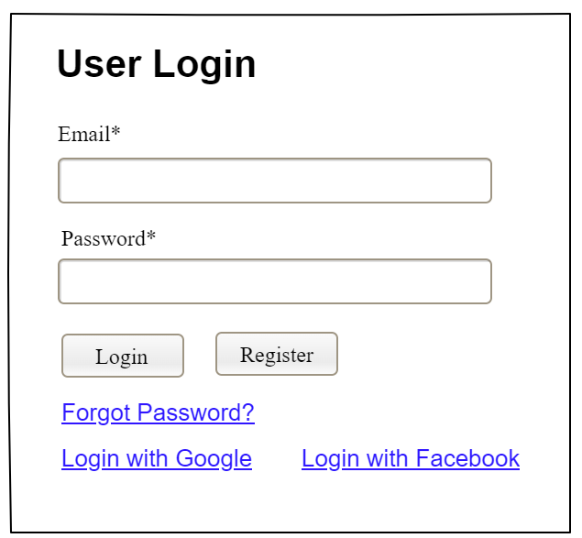

Field Name | Field Type | Description
Email* | Text Box | This is for user to input valid email address for logging in
Password* | Password Box | This is for user to input password for logging in
Login | Button | User clicks to authenticate him/herself into the system with provided email & password
Register | Button | User clicks to redirect to the User Register page for registering new user account to access the system
Forgot Password? | Hyperlink | User clicks to redirect to the Password Reset page for resetting his/her forgot password
Login with Google | Hyperlink | Allow user to login with his/her Google account
Login with Facebook | Hyperlink | Allow user to login with his/her Facebook account

Database Access
Table | CRUD | Description
User | R | Verify UserName & Password information
Setting, User | R | Specify the authorizations of the logged-in user

SQL Commands:
1/ Verify UserName & Password information
SELECT user_id, full_name, email, image_url, status
FROM user WHERE user_name = ? AND password = ?

2/ Specify the authorizations of the logged-in user
SELECT mapped_values FROM setting WHERE setting_id = ?
SELECT setting_name, mapped_values FROM setting WHERE setting_id IN (?)

b. Setting List

UI Design
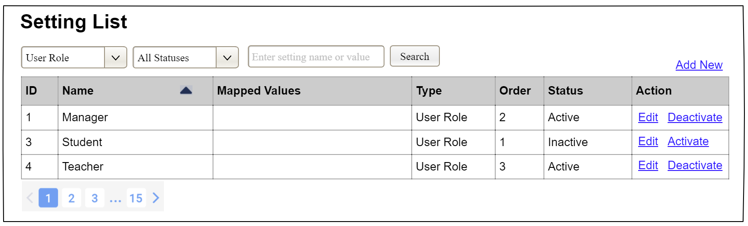

Field Name | Field Type | Description
Search Fields
Setting Type | Combo Box  Single-Choice | Filled with the list of current active setting types  Allow to filter the list by setting type;  Default value is “All Types”
Setting Status | Combo Box  Single-Choice | Values: All Statuses (default), Active, and Inactive  Allow to filter the list by status  Default value: “All Statuses”
Search Phase | Text Box  String (30) | Allow to search using the name or map values  Default value: blank
Search | Button | Click to refresh the list with the defined filter(s) and search phrase.
Add New | Hyperlink | Click to open the Setting Details page for adding new setting (master data)
Data Table
ID | Integer | Auto-increased identifier of the setting
Name | Text | Name of the setting
Mapped Values | Text | Supplementary information for the setting
Type | Text | Type of the setting
Order | Integer | Display order of the setting: the order of the setting type, displayed among the list of settings with the same type
Data Actions
Edit | icon | Click to open the Setting Details page for updating the relevant setting (master data)
Activate | icon | Shown when the data status is inactive. This is to activate the relevant setting (master data)
Deactivate | Ion | Shown when the data status is active. This is to deactivate the relevant setting (master data)

Database Access
Table | CRUD | Description
Setting | RU | Query the list of current settings from the database  Update status of a specific setting

SQL Commands:
1/ Query the list of current settings from the database
SELECT setting_id, setting_name, mapped_values, type_id, display_order, status
FROM setting WHERE (setting_type = ?) AND (status = ?) AND (setting_name LIKE ?)

2/ Update status of a specific setting
UPDATE setting SET status = ? WHERE setting_id = ?

c. Setting Details

UI Design
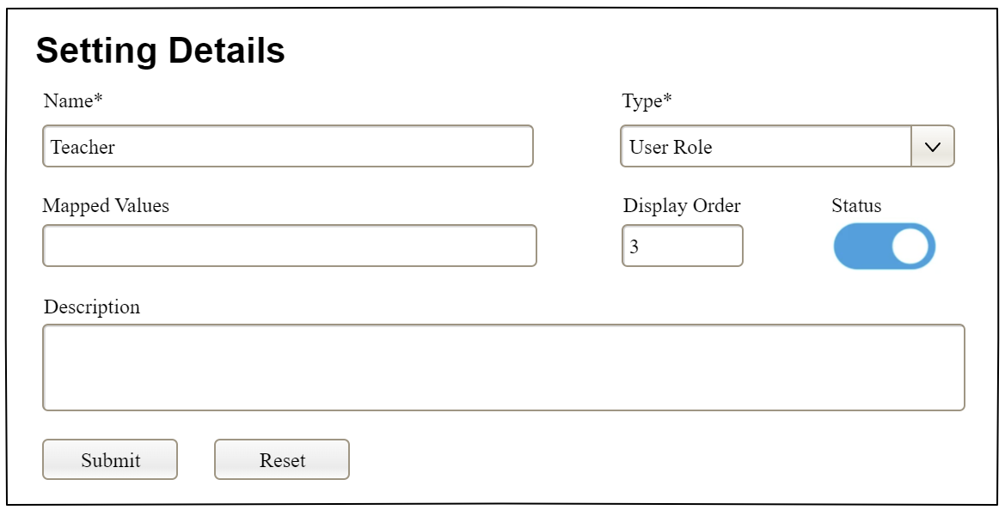

Field Name | Field Type | Description
Name* | Text Box  String (20) | Name of the setting
Type* | Combo Box  (Single Choice) | Type of the setting, filled with the list of setting types  Default value: the first type in the list
Mapped Values | Text Box  String (50) | Supplementary information for the setting (if any)
Order | Text Box  Integer (>=0) | Display order of the setting: the order of the setting type, displayed among the list of settings with the same type
Status | On/Off button | Status of the setting: Active or Inactive  Default value: Active
Description | Text Area  String (200) | Description of the setting
Submit | Button | Click to store new or updated setting details
Reset | Button | Click to reset the changes use has made on the screen fields back to the initial values when the screen is loaded

Database Access
…

IV. Appendix

1. Assumptions & Dependencies
[Record any assumptions that were made when conceiving the project and writing this vision and scope document. Note any major dependencies the project must rely upon for success, such as specific technologies, third-party vendors, development partners, or other business relationships.]
<<Sample:
AS-1: Systems with appropriate user interfaces will be available for cafeteria employees to process the expected volume of meals ordered.
AS-2: Cafeteria staff and vehicles will be available to deliver all meals for specified delivery time slots within 15 minutes of the requested delivery time.
DE-1: If a restaurant has its own on-line ordering system, the Cafeteria Ordering System must be able to communicate with it bi-directionally.
>>

2. Limitations & Exclusions
[Identify any product features or characteristics that a stakeholder might anticipate, but which are not planned to be included in the new product]

3. Business Rules
[Provide common business rules that you must follow. The information can be provided in the table format as the sample below]
<<Sample
ID | Category | Rule Definition
BR-01 | Constraints | Delivery time windows are 15 minutes, beginning on each quarter hour.
BR-02 | Constraints | Deliveries must be completed between 10:00 A.M. and 2:00 P.M. local time, inclusive.
BR-03 | Facts | All meals in a single order must be delivered to the same location.
BR-04 | Facts | All meals in a single order must be paid for by using the same payment method.
BR-11 | Constraints | If an order is to be delivered, the patron must pay by payroll deduction.
BR-12 | Computations | Order price is calculated as the sum of each food item price times the quantity of that food item ordered, plus applicable sales tax, plus a delivery charge if a meal is delivered outside the free delivery zone.
>>

4. ..

